Association for the Advancement of Assistive Technology in Europe
Annual report 2016-2017
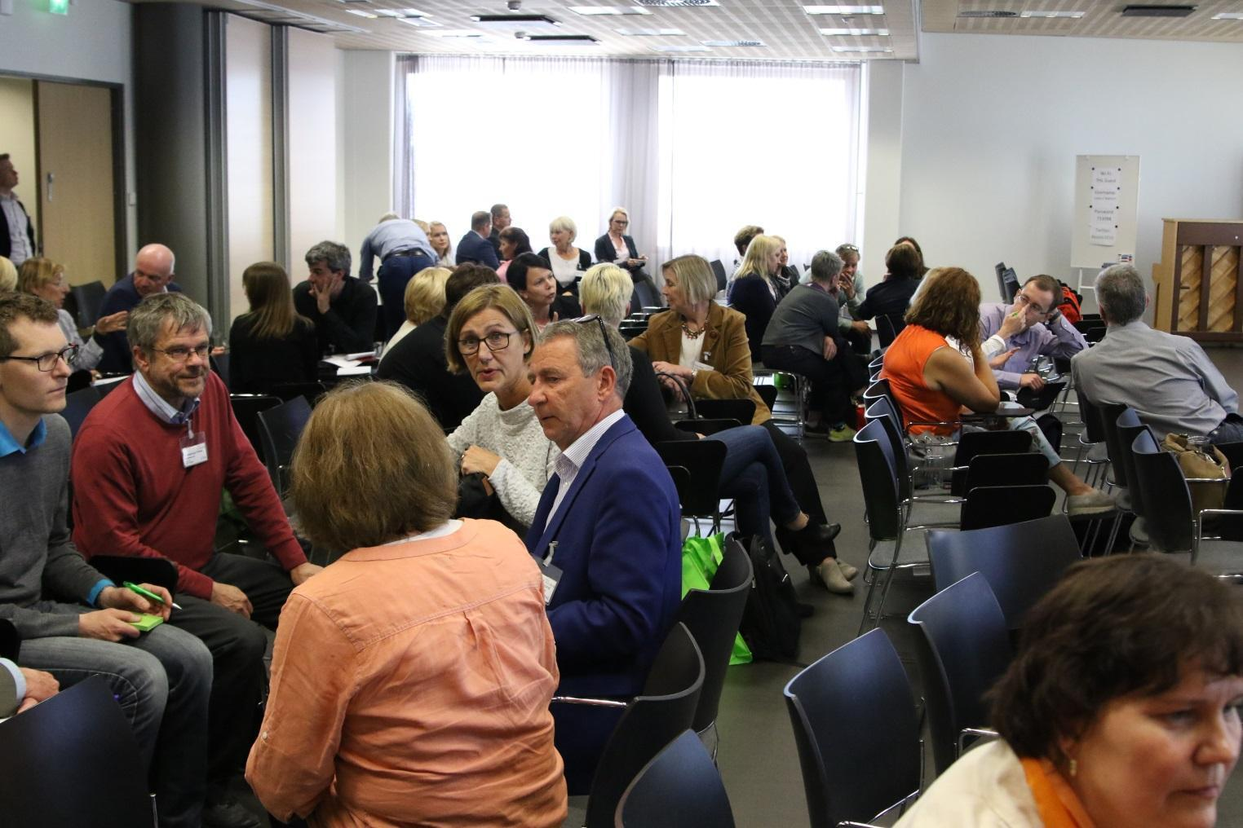Helsinki workshop 2016, photo THL

Authors: Board of AAATE, April 2018
Table of Contents
1. Introduction 3
2. Activities 4
2.1. Workshop Helsinki 2016 4
2.2. Conference 2017 5
2.3. Governance of AAATE 6
2.3.1. Board composition 6
2.3.2. Board meetings 6
2.4. International collaboration 6
2.4.1. Alliances and participation in collaborative work 6
2.4.2. Participation in official meetings and conferences on behalf of AAATE 8
2.5. Communication and Publications 10
2.5.1. The Journal Technology and Disability 10
2.5.2. Website 10
2.5.3. Other communication matters 11
2.6. Projects 11
2.6.1. Introduction 11
2.6.2. InLife Project 11
2.6.3. ProAct 12
2.6.4. The Risewise project 12
2.6.5. Entelis 12
3. Organization 13
3.1. Members 13
3.2. Secretariat 14
3.2.1. Staff & Responsibilities 2016-2017 14
3.2.2. Main Tasks 2017 14
3.3. Financial report 15
4. Acknowledgements 18
5. Final considerations 19
Annex 1 - List of Institutional Members (IM) 20
Annex 2 - List of National Contact Persons (NCP) 23
Annex 3 - Audit reports on the financial statements of AAATE 25

Introduction
This report provides an overview of the activities of the Association for the Advancement of Assistive Technology in Europe (AAATE) during the years 2016-17. Its members come from over 100 European Organisations. The AAATE is an association driven by its members who contribute voluntarily to the realization of its mission: to stimulate the advancement of assistive technology for the benefit of people with disabilities, including elderly people. Advancement should be understood to mean activity that improves availability, access to and quality of both AT and associated services, and hence, benefits AT users. AAATE is fully committed to implementation of the UN Convention on the Rights of Persons with Disabilities.
In order to reach these objectives AAATE works with a wide variety of stakeholders to include their valuable perspectives and approaches. This multi-perspective approach also extends beyond Europe through involvement in collaborations such as the Global Alliance of Assistive Technology organisations and the World Health Organisation GATE initiative.
In this period national financial stringencies have put many AT services and indeed other services for people with disabilities and the elderly under threat. As an example Finland lost its national AT information and guidance service at the Finnish National Institute for Health and Welfare (THL). Current reports suggest it is already missed by the regional/local services and certainly by the AT research community where they were proactive. This period has also seen the loss of one of the AAATE’s previous presidents, Niels-Erik Mathiassen, who was a very valued and active champion of our field. He will be sadly missed.

Activities

Workshop Helsinki 2016
The AAATE Workshop 2016 - Assistive technologies and other technologies for elderly people supporting independent living at home - was held in Helsinki 8th and 9th of June 2016. The workshop was organized together with the Ministry of Social Affairs and Health Finland as part of the activities of the Finnish Presidency of the Nordic Council of Ministers in 2016, by the National Institute for Health and Welfare, Valli – The Finnish Union for Senior Services, VTKL – The Finnish Association for the Welfare of Older People and Kuopio University Hospital.
The AAATE workshop 2016 gathered about 90 experts from around Europe to discuss and exchange their expertise. Participants gave good feedback of the workshop content and organization. One of the participant stated “This was one of the best meetings I have attended. I have already being telling my colleagues in Ireland about this society.” A small exhibition was hosted alongside the workshop.
Participants were asked what themes they would like for a next workshop. The following topics were suggested by 34 participants:
- Communication and assistive technology (AAC);
- Robotics in education of children with disabilities;
- User experiences of AT;
- Robotics, use of technology in care, education and training with elderly people;
- Cost-benefit studies and presentations;
- Ethics and responsibility.
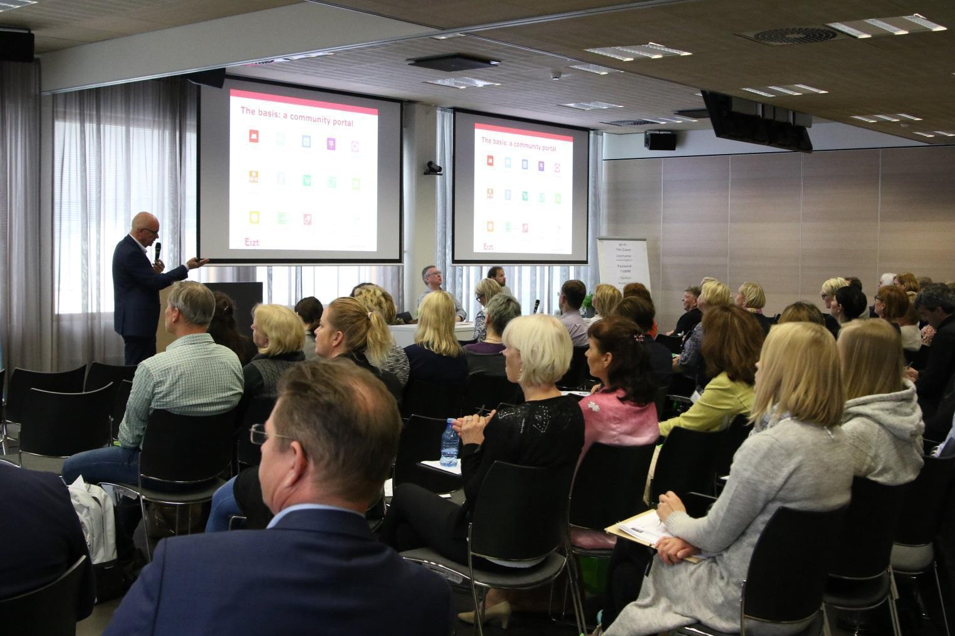
Workshop Helsinki, photo THL

Conference 2017
The reporting period saw an innovation in the bi-annual conference where the board entered into an agreement with the Centre for Assistive Technology and Connected Healthcare in the UK to run a Congress of events that incorporated new styles of content. The President of AAATE was a member of both. A significant investment was planned to promote the conference and to innovate the programme (e.g. involvement in 8 international committee meetings between June 2016 and August 2017). The board had a strong influence on the scope and the finalising of the programme; there was an intent to learn from this.
The Congress was spread across 4 days. Two single day programmes (one of which was the T4I2017 conference) attracted 150 delegates while the main 2 day conference 265. This was a significant improvement on many previous conferences but below the aimed at target of 350-400 delegates.
Feedback on the conference provided useful insights to the way forward on future AAATE conferences. For instance it confirmed that for most delegates the total cost of the event, accommodation and travel was important; the mix of topics included was liked regardless of how many were specifically of use; the standard length of 15 minute talks with 3 minutes for questions, the novel 7 minute talks and 2 minutes for questions, and the novel platform sessions (where there were just 2 parallel sessions and each contained either a single or two talks filling an hour), were all liked. The main challenges identified were: the Congress website was felt poor on accessibility; three days duration of the main conference was preferable to two (two was chosen to reduce cost and financial risk); and, too many choices in registration, paper submission and events caused some delegates to feel the Congress was confusing.
Due to the innovations in AAATE 2017 and the desire to learn from it, a decision was taken to give time for the board to reflect on the feedback and their experiences of greater involvement - delaying the announcement for AAATE 2019. The following are the main points of these reflections :
- The board should continue on the basis of their greater involvement in the Conference content but operating as efficiently as possible;
- The nett overall investment of time of the board was high and it has been noted that in the future the President of the AAATE should not also be the main person organising the conference;
- Substantial investment of time in arranging a specific new agreement for each conference should be avoided - instead the AAATE should return to offering a standard contract to hosts;
- As much as possible the total cost to attend the conference for delegates should be considered - in an ideal world the price for all three main components should be as low as possible;
- The conference book is expensive to include - especially in human resources to manage reviewing and proofreading - but also to pay for its production. An alternative strategy to seek only extended abstracts and publish papers for example through the Technology & Disability Journal should be planned as an alternative;
- Have a 3 day event with a range of presentation options and style of sessions (i.e. symposia, workshops, debates).

Governance of AAATE

Board composition
During the period 2016-2017 the board of AAATE was composed as follows:
Peter Cudd (President), Luc de Witte (President elect), Evert-Jan Hoogerwerf (Past president), Helena Hemmingsson (Treasurer), Katerina Mavrou (Communication officer), Dominique Archambault (Projects Officer), Anne Kanto-Ronkanen (Secretary).

Board meetings
In each calendar year in the reporting period the board held the usual two face to face meetings - one in each year at the workshop or the conference. In 2016 there were 2 online conference meetings. In 2017 there were 8 online meetings. Additionally there were 8 various committee meetings associated with the implementation of the 2017 Congress and smaller group meetings regarding different matters of board actions. The Board meetings have been supported by networking and frequent communication via email. The main topics in the board meetings have been the changing scope of the field of assistive technology and changes in service offerings (especially in Europe), the journal, GATE, managing cash flow, new ways to operate our future conferences and some specific issues for AAATE 2017 and different projects and project proposals.

International collaboration

Alliances and participation in collaborative work
GATE
On request of the WHO the AAATE took on the assignment to develop the Global Priority Research Agenda for improving access to high-quality affordable assistive technology. This process involved the sister organisation RESNA and more than 60 colleagues around the world. The resulting research agenda was published by the WHO in 2017.
EASPD
Based on the cooperation agreement signed between the EASPD (European Association for Service Providers for People with Disabilities) and the AAATE in 2011, the AAATE takes an active role in the PCT group (Person Centered Technology). The PCT Mission Statement outlines that the partnership intends to work on:
- Partnership – Develop existing and new partnerships with a focus on PCT policy issues e.g. AAATE, EDF etc.);
- Networks – Contact and use existing networks to raise the issues of PCT and disability (e.g. BATA, ANED, AAL etc.);
- Information and Support – Devise a programme to provide information and support to EASPD members, in particular for service providers of residential support (pursue through ESF or EU project funding);
- Project Development and Research – There is an increasing interest in PCT in new technology solutions, in service delivery issues including ethics, and in impact on quality of life and resources. EASPD will pursue involvement in these areas;
- Lobby – To continue to work in partnership with EU and national official and policy makers to raise the issues associated with PCT and disability building on the findings of the ‘ImPaCT in Europe’ project.
The PCT SIG has formed a core group that consists of:
- EASPD (Luk Zelderloo)
- Hft (Steve Barnard)
- AAATE (Klaus Miesenberger, Evert-Jan Hoogerwerf)
- AIAS (Evert-Jan Hoogerwerf)
- ‘Open the Windows’ (Lidija Krstevska Dojcinovska)
- ASPA (Vesa Salmi)
The group meets regularly in telcos and once or twice a year face to face to set-up and work on an annual agenda following the above mission. Activities in 2017 included:
- Planning, contribution and participation in the Workshop on Assistive technologies for the inclusion of people with disabilities in society, education and jobs, January 31st 2017, Brussels;
- Planning, contribution and participation in EASPD’s Annual Conference in Belfast, 14 to 16 June 2017 in Belfast as part of the first World Conference on Supported Employment. The conference focussed on Employment for All – A Global Perspective and aims to challenge everyone to improve access to the employment market by bringing the employers closer to those furthest from the labour market and in doing so recognising the challenges and changes that we as professionals may face. To help through this process the conference themes were: the Right to Work, the Economy and the Employers, Tools and Methodologies, Legal Frameworks and Policy;
- Participation in and contribution to the ENTELIS activities at the EVBB’s Annual Conference in Malta (October 4-7-2017) on “Vocational Training in the Context of an Inclusive Society - Experiences, Demands and Perspectives”;
- Contribution and participation in the Workshop on Digital Health Conference, Tallinn, Estonia 16-18th October 2017;
- Planning, contribution and participation in EASPD Annual Conference in Podgorica (Montenegro) on 26-27 October 2017, focussing on supportive communities and sustainable development to facilitate changes required in support services to embrace and implement the human rights approach, looking at the connection between the UN Sustainable Development Goals and the UN Convention on the Rights of Persons with Disabilities;
- Formulating a letter outlining the concerns about draft Horizon Work Programme 2018-2020 no longer including disability, accessibility and assistive technologies;
- Outlining, tendering, supporting and controlling a study on “Barriers to the wider deployment of person centred technology in services for persons with disabilities”, to be finished and disseminated in 2018;
- Work on several project proposals and network initiatives including AAATE;
- Contribution to EASPD’s newsflash.
Alliance of Assistive Technology Professional Organizations
In 2016 the Alliance of Assistive Technology Professional Organizations was founded. This incorporates AAATE, RESJA, RESKO, RESNA, and TREATS in cooperation working to advance the field of assistive technology and rehabilitation engineering to benefit people with disabilities and functional limitations of all ages. The first year has seen limited activity with a meeting held at the WHO Great summit event in Geneva and the AATPO representatives publishing a response (see https://doi.org/10.1080/17483107.2017.1379102 ) to Marcia Scherer’s important strategic commentary: Scherer, M. J. (2017). Technology adoption, acceptance, satisfaction and benefit: integrating various assistive technology outcomes. Disability and Rehabilitation: Assistive Technology, 12(1), 1–2. doi:10.1080/17483107.2016.1253939
InLife
The Association, through its participation in the InLife project, was actively involved in the elaboration of “Recommendation 2016” concerning standards on e-Accessibility and e-Inclusion and together with the International Information Centre for Terminology (Infoterm) leads the way by officially endorsing it and inviting other organisations to endorse it as well.. http://aaate.net/2017/04/14/aaate-endorsed-the-recommendation-2016-concerning-standards-on-eaccessibility-and-einclusion/
ENTELIS
An important area of collaboration with different European stakeholders is the ENTELIS network. the AAATE has been a member since its early beginning as a project and is among the founding members of the post-project network. To this extent a collaboration agreement was signed with the European Association for Service Providers to Persons with Disabilities and the European Association of Institutes for Vocational Training. The network aims to reduce the digital divide and its activities are directed by a roadmap for action outlined in a white paper for digital inclusion. The activities of the network in 2017 are reported in an annual report that can be downloaded from the ENTELIS website (www.entelis.net).

Participation in official meetings and conferences on behalf of AAATE
The past-president took part in an Expert Group Meeting on Disability Prevention and Rehabilitation organised by the Regional WHO Office for South-East Asia on 28-30 July 2016 in Jakarta, Indonesia, on which occasion he also represented AAATE. The meeting was organised to exchange good practice and to further the development of regional collaboration regarding AT. The invitation from WHO came after earlier participations of Hoogerwerf in WHO events in the USA, Europe and in Asia.
Several board members participated in the first meeting of the WHO GATE initiative in Geneva, ie the Global Research, Innovation, and Education in Assistive Technology
(GREAT) Summit, on 3-4 August 2017. This meeting aimed to bring together 100 top global researchers, innovators and educators who are carrying out research or offering training programmes related to assistive technology policy, products, personnel, provision, and use. The main aims included the advancement of the global priority research agenda on assistive technology and the establishment of the thematic research collaborations in improving AT effects, impact, policies, systems, human resources, standards, methodologies and funding opportunities. among others the meeting resulted in 5 position papers, in which AAATE members contributed as authors and co-authors.
The president participated in the Science Technology Options Assessment Panel (STOA) of the European Parliament funded foresight project “Assistive technologies for the inclusion of people with disabilities in society, education and jobs” lead by Linda Nierling of Karlsruhe Institute of Technology. The project selected to focus on three groups, people who are deaf or hard of hearing, are Blind or have sight loss, and people with autism. As well as being interviewed attendance at a meeting in the European Parliament was involved.
Workshop delegates for “Assistive technologies for the inclusion of people with disabilities in society, education and jobs” STOA project.

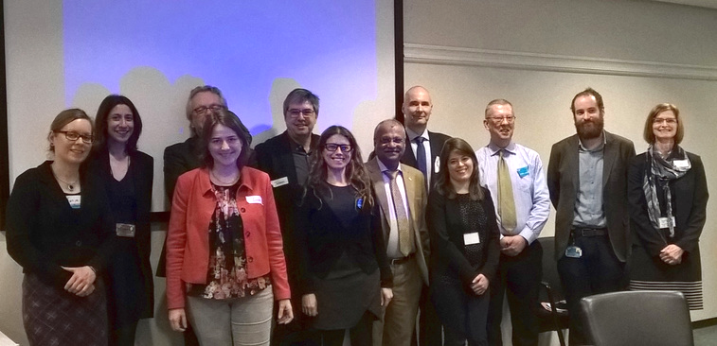
Tanja Bratan, ETAG, ISI Fraunhofer; Neha Dave, Med Tech Europe; Leonhard Hennen, KIT, ETAG; Linda Nierling, KIT, ETAG; Johann Čas, ETAG, OeAW; Maria Joao Maia, KIT, ETAG; Chapal Khasnabis, WHO; Antti Raike, Aalto University; Aurélie Baranger, Autism Europe; Peter Cudd, AAATE and CATCH; Philipp Boucher, STOA; Lieve van Woensel, STOA. Photo: Maria João Maia
The findings have been reported online on the Karlsruhe Institute of Technology website and under AT for people with disabilities - on the European Parliament website.
On the 23rd of November 2017 Evert-Jan Hoogerwerf presented on gender, technology and disability during the Genova Smart Week. The title of the presentation was “It won't be smart until it is inclusive: the Risewise project”. The session was attended by approximately 100 people. The costs were paid by the City of Genova.
Klaus Miesenberger represented the AAATE in meetings at the Annual Conference Technology and Disability organised by the California State University Northridge (CSUN) in March 2017. The conference includes meetings amongst stakeholders like RESNA and other sister organisations focussing on mutual exchange and cross-marketing of activities as the conference and the workshop.

Communication and Publications

The Journal Technology and Disability
In 2016 four issues of the Journal Technology and Disability were published and in 2017 three. In total the journal received 37 new manuscripts for review and 45 revised manuscripts. 22 manuscripts were accepted, 8 rejected and other authors were invited to revise their manuscript.
The Editorial board consisted of the following persons:
Editor in chief
Prof Luc de Witte (Zuyd University of Applied Sciences (until october 1)/University of Sheffield (since october 1)
Associate Editors:
Dr Steven Ariss, DPhil (University of Sheffield, s.ariss@sheffield.ac.uk
Prof Dominique Archambault (Université Paris 8, dominique.archambault@univ-paris8.fr)
Dr Katerina Mavrou (European University Cyprus, K.Mavrou@euc.ac.cy).
For the first time the AAATE conference has produced an e-Book as its published format. Over 200 articles were received. A significant minority were accepted as is, but many had minor to moderate changes needed. The remainder had potentially challenging feedback from one or both reviewers. The editors chose to offer most of these authors the opportunity to improve their manuscripts rather than turn them down. Nearly all rose to the challenge. In line with the policy to accept contributions that contributed to knowledge but that were not necessarily solely or exclusively academic meant that a good mix of science, practice, development and some policy was achieved.
In another innovation authors could opt to submit a paper to the MDPI - Technologies journal for open publication in an AT special issue; the Congress organisers (i.e. AAATE board and CATCH) with IOSPress agreement allowed this second journal to canvas Congress contributors. Many have taken advantage of this opportunity.

Website
In March 2016, the website engine that we were using was discontinued, and it was decided to change to a new system, based on an open source software: WordPress. The migration of information pages was relatively fast, despite some technical problem during the first week. A new system for management of members was developed (which is shared with 2 other associations). It is developed as a wordpress plugin and will be made available to other associations. It includes automatic generation of invoices, credit card payment, members account management, emails to members, management of events and other features. It is still under development.

Other communication matters
A strategy document regarding communication and social media was developed by our communication associate Sabine Lobnig. The overall objectives of the AAATE communication strategy in 2016-2017 were:
- to strengthen the AAATE community;
- to sustain a coherent image of AAATE as an active and professional sector organisation;
- to promote the circulation of quality information towards the members;
- to promote the activities that see AAATE involved (conference, workshop, ENTELIS network);
- to broadly disseminate the outcome of the projects that see AAATE involved.
AAATE uses the following channels to communicate:
- A Twitter account @AAATE_net;
- The AAATE LinkedIn Group;
- The AAATE website;
- Mailchimp – emailing.

Projects

Introduction
For AAATE the collaboration in projects is an important way of realising its mission. Guidelines for project participation have been defined and are published on the website. The aim of AATE is to avoid direct competition with its members, but, on the contrary, to be of added value for them. AAATE is active in InLife, ProACT and Risewise, three Horizon 2020 funded projects as partner for background research and dissemination. AAATE has also created the conditions for the ENTELIS network to be created. In other words, participation is factual, effective and of high quality.

InLife Project
The InLife project (2016-2018) has passed its annual reviews and is about to be concluded. The project has developed a large number of apps targeting older adults with mild cognitive impairment and a unique platform for hosting these apps and wider AAL solutions. AAATE has developed a communication strategy and has organised different workshops in the framework of the project, with and without other European projects, among which a very nice seminar on Change management as a success factor in the implementation, scaling up and transfer of digital health & social care solutions, and the Strategic aspects of standardisation and certification in the field of eAccessibility & eInclusion. Both workshop reports are available on the AAATE website.

ProAct
The ProAct project is a research project funded under the Horizon 2020 programs. It started in 2016 and it will end in 2019. Its purpose is to develop and test a platform for multimorbidity management and integrated care, supporting the independence and quality of life of older adults living with multimorbidity, e.g. various chronic conditions. The role of AAATE is to contribute to a European wide study on factors that impact on the transferability potential of integrated care platforms. A researcher has been contracted, Maite Ferrando, to implement the research and to contribute to the development of a European transferability model.

The Risewise project
The RISEWISE project is a Marie Sklodowska-Curie Research and Innovation Project (H2020-MSCA-RISE-2015). The aim of the project is to explore questions in relation to gender and disability. The project focuses on women with disabilities as active agents, trying to identify needs and best practices in several EU countries, representing different cultural and socio-economic environments. Within Risewise a special interest group is working on Gender, disability and technology. It involves colleagues from Turkey, Spain, Sweden and Italy. The role of AAATE until this moment has been limited to attending meetings, but the expectation is that in the future we will benefit from work of seconded researchers supporting the conference 2019.

Entelis
The ENTELIS Project ended in December 2016. A key deliverable is the “White paper for digital inclusion” (downloadable from www.entelis.net). AAATE together with EASPD (The European Association of Service Providers for Persons with Disability) and EVBB (European Association of Institutes for Vocational Training) signed a Memorandum of Understanding on the 19th of October 2016 in Brussels by which ENTELIS is now established as a network or organizations that has a structure similar to that of the European Innovation Partnerships. Interested organizations formalize their membership by committing work such as sharing their best practice, developing innovative policies, strategies and tools to reduce the digital divide. A Call for Commitments was launched through the website and the 2017 work plan was developed. A report of activities is available on the website.

Organization

Members
Table 1: Memberships 2017
Membership | 01/17 | Cancelled | New | 01/18
Individual | 84 | 21 | 37 | 100
Institutions/Inst. Members | 44/130 | 5/14 | 5/16 | 44/132
Students | 6 | 2 | 0 | 4
Total | 44/220 | 5/37 | 5/53 | 44/236

Members and Institutional Members: AAATE has 236 members from 33 countries. Contact details and Institutions of members are listed on the website: Members list at http://aaate.net/about-aaate/members-list/ and Institutional Members List at http://aaate.net/institutional-members-list/. Members have access to a number of benefits, including the Members area on the website http://aaate.net/wp-login.php and access to the Technology and Disability journal. Institutional Members are highly appreciated by AAATE as established collaborations that offer further opportunities for promoting the vision of AAATE through research, dissemination activities, position papers and other shared activities in order influence to policy and practice on the impact of technology to the rights of people with disabilities in Europe and beyond. The list of Institutional members of 2017 is available in Annex 1.
National Contact Persons: For facilitating Members’ and other interested parties contact AAATE, the association has National Contact Persons in 28 European countries. National Contact Persons are ambassadors of AAATE that share the mission and objectives of the association and promote these in their countries. Their role is to create awareness on assistive technology and the role of AAATE in events and other activities in their countries, communicate with members and recruit new members in their countries, and actively collaborate with the association’s board in promoting and supporting various activities. The contact details of NCPs are available on the website http://aaate.net/about-aaate/national-contact-persons/. AAATE appreciates existing and new members interest in becoming NCPs in additional countries. The list of NCPs in each country for 2016 is available in Annex 2.

Secretariat
The secretariat of the AAATE is in John Kepler University in Linz , Austria.
Contact information to the office:
AAATE office Johannes Kepler University
c/o Institute Integriert Studieren
Altenberger Str. 69
4040 Linz,
Austria
office@aaate.net
www.aaate.net

Staff & Responsibilities 2016-2017
Office
Klaus Miesenberger - head of secretariat, scientific counselor
Priska Feichtenschlager - financial administration, human resources, project administration
Silke Haider - secretary
Christian Schult - Technician & ENTELIS project - ends with 03/2016
Project manager
Evert Jan Hoogerwerf - (2016-2018) Overall management tasks related to administration and projects
Specific assignments on Projects
Renzo Andrich - (2015-2016) senior researcher, project ENTELIS
Christian Schult - (2015 - 2016), technician, project ENTELIS
Peter Cudd - (2016-2018) Senior Project Led, project InLife
Maite Ferrando - (2017-2019) Researcher ProACT project
Leo Lewis - (2017-2019) Senior advisor ProACT project
Sabine Lobnig - (2017-2018) Communication expert IN LIFE

Main Tasks 2017
Office main tasks has been:
- Maintenance and development of AAATE website & tool 01-03/2016 - afterward only administration
- Financial management (support of treasurer, accounting, invoicing & reminding)
- Support of AAATE 2017 conference
  - operation review-process
  - organizing of program
  - operation financial tasks (conference fees, credit card payment, commission business)
  - operation online-registration
  - structure for standardization workshop and Special Interest Group
- Support and development of ideas for further events (workshops, conferences)
- Administration of projects (ENTELIS, InLife, ProAct, RISEWISE)
- Do-to-day business (mass-mails, newsletter)

Financial report
The account balance on 31/12/2017 was € 116,450.36. Tables 2 and 3 present the financial development of AAATE over the years 2013 - 2017.

Table 2 Financial balance, overview of 5 terms without projects
Summary | 2017 | 2016 | 2015 | 2014 | 2013
Income | 14,023 | 13,856 | 31,748 | 11,600 | 34,770
Production | 8,154 | 11,811 | 8,084 | 10,580 | 9,705
Projects |  | 5,497 | 4,411 | 3,680
Administration | 11,353 | 7,159 | 11,198 | 6,467 | 10,874
Surplus | -5,484 | -10,610 | 8,055 | -9,127 | 14,191

Table 3 Financial balance of the projects
Summary | 2017 | 2016 | 2015 | 2014 | 2013
Income | 33,836 | 59,578 | 25,929 | 23,484 | 12,000
ProAct | 0 | 26,594
InLife | 8,980 | 0 | 15,229
ENTELIS | -2,759 | 19,484 | 0 | 19,484
AAATE 2017 | 27,615
GATE meeting |  | 13,500 | 10,700
eAccess |  |  |  | 1,500 | 6,500
ETNA |  |  |  | 2,500 | 5,500
Expenses | 61,751 | 20,100 | 34,363 | 9,958 | 758
AAATE 2017 | 27,615 | 707
Risewise | 517
ProACT | 6,555
ENTELIS |  | 14,654 | 11.309 | 9,643 | 0
InLife | 26,564 | 4,739
GATE meeting |  |  | 23,054
eAccess+ |  |  |  |  | 758
General costs | 500 | 0 | 0 | 315 | 0
Surplus | -27,915 | 39,478 | -8,434 | 13,526 | 11,242

Table 5 Balance 2017
ASSETS | € |  | LIABILTIES | €
Amounts Due |  |  | Capital
Debtors membership | 1,730 |  | Result 2017 | 33,399
Debtors AAATE 2017 | 2,840 |  | Opening Balance | 152,728
Total Amounts Due | 4,570 |  | Total Capital | 119,329
Liquid Assets |  |  | Liabilities
Bank account | 116,450 |  | Liabilities AAATE | -1,150
Total Liquid Assests | 116,450 |  | Liabilities Sheffield | 2,841
 |  |  | Total Liabilities | 1,691
TOTAL ASSETS | 121,020 |  | TOTAL LIABILITIES | 121,020

Acknowledgements
One AAATE diamond for outstanding work in the advancement of AT in Europe was awarded in 2017 to Paul Timmers for accepting the invitation to open our 2017 conference with a Plenary talk covering a historical perspective of AT in Europe and his vision for where AT should head - drawing on his considerable experience in his roles in innovation in the DGs of the European Commission. Paul has been Head of Unit eInclusion (DG Connect) and thereby played a key role in advancing research and application of AT and accessibility, in particular also in the AAL domain.

Final considerations
Assistive Technology is more important than ever. Growing numbers of people with disabilities in health and social care systems that are confronted with shortages of staff and money put an increasing pressure on health and social care systems. Making optimal use of the potential of Assistive Technology is one of the obvious solutions. Also for a very different reason AT is becoming more important: the increasing use of digital media creates a major barrier for many people to actively participate and make use of the possibilities the ‘digital era’ offers. This is a growing field in AT. In order to ensure that people with disabilities, including many older persons, specific solutions are needed. Unfortunately these topics do not get the attention they require in national and international policies. There is work to do for organisations like the AAATE!
The WHO-GATE initiative is a great stimulus to increase our influence and to participate in the challenge to ensure improve access to high-quality and affordable AT and related services across the world.
In the coming years the AAATE intends to grow in membership and influence. The ambition is to play an active role in Europe, among other things by participating in relevant EU project. We also intend to play an active role on a global level, with GATE as core focus.

Annex 1 - List of Institutional Members (IM)
(at 2017-12-31)
Austria
- Johannes Kepler Universität Linz
- Hilfsgemeinschaft der Blinden und Sehschwachen Österreichs
Belgium
- KOC - Kenniscentrum Hulpmiddelen van het VAPH
- University of Antwerp
- VIVES University College
Cyprus
- European University Cyprus
Czech republic
- VŠB - Technical University of Ostrava
Denmark
- The National Board of Social Services
Finland
- Oulu University of Applied Sciences
- Satakunta University of Applied Sciences
- Finnish Association on Intellectual and Developmental Disability
- Union for senior services in Finland
France
- THIM/CHArt EA 4004 - Université Paris 8-Vincennces-Saint-Denis
- IFRATH
Germany
- Forschungsinstitut Technologie und Behinderung - Der Evangelischen Stiftung Volmarstein
Great Britain
- Disabled Living Foundation
- Smile Smart Technology LTD
- Rat group - University of Sheffield
Greece
- FORTH ICS
Hungary
- Andrássy University Budapest
Ireland
- National Assistive Technology Training Service Enabled Ireland
- National Disability Authority
Italy
- Emilia Romagna's Centre For Assistive Technology
- National Research Council
- HELPICARE by Didacare srl
- University of Pisa
- Fondazione Don Carlo Gnocchi Onlus
- Instituto Leonarda Vaccari
- Associazione GLIC
- Politecnico Di Milano - Polo Territoriale die Como
Lithuania
- The Center of Technical aid for Disabled people - Ministry of Social security and Labour
Netherlands
- Zuyd University
- Vilans
Norway
- The Norwegian Labour and Welfare Service
- Statped
Portugal
- Sociedade Portuguesa de Engenharia de Reabilitação, Tecnologias de Apoio e Acessibilidade
Spain
- Centre de Vida Independent
- Fundacion Vicomtech
Sweden
- Linköpings Universitet
Switzerland
- Raising the Floor - International Association
- iHomeLab - Lucern University of Applied Sciences and Arts
- DAISY Consortium
- ETH Zürich
- Active Communication AG
USA
- The Paciello Group

Annex 2 - List of National Contact Persons (NCP)
(at 2017-12-31)

Austria | Klaus Miesenberger | University of Linz
Belgium | Jan Engelen | Catholic University Leuven
Croatia | Ines Delzotto | Dnevni centar za rehabilitaciju Veruda Pula
Cyprus | Katerina Mavrou | European University Cyprus
Czech Republic | Marek Penhaker
Denmark | Anne Christensen | Danish National Board of Social Services
Estonia | Hille Maas
Finland | Outi Töytäri | National Institute for Health and Welfare (THL)
France | Dominique Archambault | University Paris 8
Germany | Christian Bühler | Forschungsinstitut Technologie-Behindertenhilfe
Greece | Constantine Stephanidis | ICS-FORTH
Hungary | Andras Arato | KFKI RMKI
Iceland | Björk Pálsdóttir | Assistive Technology Center – Icelandic Health Insurance
Ireland | Gerald Craddock | Centre for Excellence in Universal Design, National Disability Authority
Israel | Reuven Katz | Technion – Israel Institute for of Technology in Haifa
Italy | Renzo Andrich | Centro di Bioingegneria, Fondazione Don Carlo Gnocchi Onlus
Netherlands | Jeanne Heijkers | Zuyd University
Norway | Terje Sund | NAV
Portugal | Leonor Moniz Pereira | Technical University of Lisboa
Serbia & Montenegro | Veselin Medenica
Slovakia | Dusan Simsik | Technical University of Kosice
Slovenia | Mojca Debeljak | University Rehabilitation Institute
Spain | Cristina Rodriguez Porrero | CEAPAT
Sweden | David Rusaw | Jönköping University
Switzerland | Bernhard Heinser | Access For All
United Kingdom | EA Draffan | University of Southampton

Annex 3 - Audit reports on the financial statements of AAATE
