INSTRUCTIONS TO RENEW MEMBERSHIP.
Paying your AAATE membership fee is an easy three step process:
- Log in on the website aaate.net with your personal account.
In case you have never created an account on the AAATE website, please contact Dominique Archambault:
dominique.archambault (at) univ-paris8.fr
In case you have lost your password, please use the facility at the bottom of the log in menu.

- Once logged in you will come to the Dashboard-page.
(see below)
On the menu on the left side you will see the item “Profile” which has several submenu’s. Please click on the subitems and update, if necessary, your data.
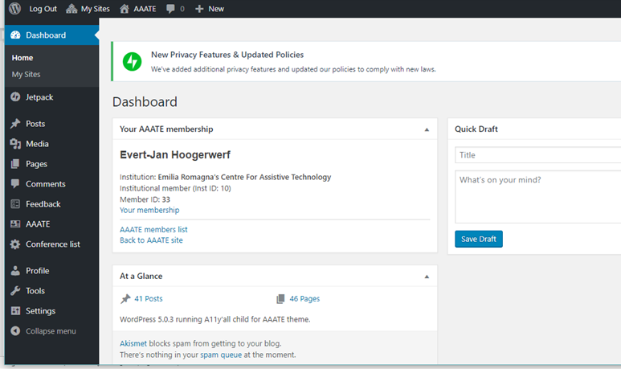
Please note that some of the information is accessible to other members as well through the Membership list that is consultable through the main menu item “AAATE” (left side of the page).
- Under “Profile” you can also assess your membership payment status. In case of outstanding invoices and you have a credit card you can immediately pay and download your invoice. Alternatively you can download your invoices and pay via bank transfer or forward the invoice to your administration (IBAN and member number is reported on the invoice). In the latter case, please check with them regularly the status of payment.
The system badly supports some credit cards. If this is your case, please pay by bank transfer.
In case you have any problems, please do not hesitate to contact the office (office@aaate.net) or the webmaster Dominique (dominique.archambault (at) univ-paris8.fr).
Good luck and thank you for your support.
Your AAATE team

