TRansport Innovation for disabled People needs Satisfaction

TRIPS workshop at ICCHP conference

10 September 2020

  - Workshop Report

This project has received funding from the European Union’s Horizon 2020 Research and Innovation Programme Under Grant Agreement no. 875588

In September 2020, AAATE’s Special Interest Group on Standards organised in collaboration with the TRIPS project consortium a workshop to discuss the role of standards for interfaces and communicated content in making public urban transport accessible for all.

David Banes opened the workshop with a brief introduction and first insights gained from the TRIPS project.

The research work done in the TRIPS project brought to light new concepts and ideas which are quite exciting in terms of enhancing mobility, but which come also with interesting challenges in terms of interoperability and integration of different data sets and the need for data to be shared across technologies and country borders.

We are interesting challenges in terms of interoperability and integration of different data sets and the need for data to be shared across technologies and country borders.

We encounter challenges in the way information on mobility, way finding etc is being communicated to the user who might be only using one app and one technology, or might also be using several apps and several technologies in parallel, or might be using no personal technology at all and rely on analogue information. How do we in such varied circumstances communicate time-critical information where temporary barriers to mobility emerge? In this context and throughout the work in the TRIPS project, standards and communication modalities seem to constantly gain in importance.

Laura Alčiauskaitė from the European Network of Independent Living (ENIL) shared primary results on how users were involved in the TRIPS project to identify barriers in the use of public transport systems.

We know by now that the numbers are impressive: around 10-15% of the population are considered having a disability and inaccessible transport systems effectively limit their equal access to important services, job opportunities, education, overall lifestyle choices and capacity for independent living.

The TRIPS project therefore aims at developing public urban transport systems that are more accessible by using a co-design approach that empowers disabled users to actively take part in the innovation of transport solutions. The end result should be an urban inclusive digital mobility solution designed by disabled users with the support of methodology experts, assistive technology suppliers, transport operators and municipalities.
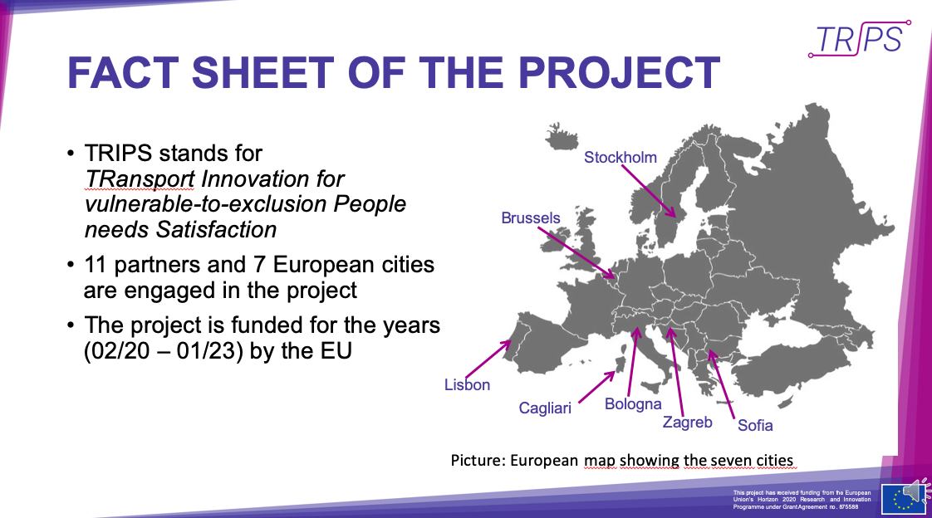
Figure 1: TRIPS stands for Transport Innovation for vulnerable-to-exclusion People needs Satisfaction. In the project, 11 partners and 7 European cities work together. The project is funded for three years by the EU. It started in 2020 and will end in 2023.

With the help of local user leads – all representatives of the disability community in the 7 project cities, the TRIPS project analyzed social media content on user experience while using public transportation in their cities and countries, and conducted qualitative interviews with transport users with disabilities.

This led to the identification of around 240 barriers in 7 categories which include: regulations, public awareness and assistance, information provision and communication, infrastructure, vehicles, stops and stations, general service quality.

We identified 240 barriers in 7 categories which range from regulations, public awareness and assistance to information provision and communication, infrastructure, inaccessible vehicles, stops and stations as well as general service quality.

In practical examples, these barriers consisted of: a ramp starting with a step, lack of assistance to get on or off the vehicle, ignorance of personnel, broken lifts, missing information, lack of reaction to complaints etc.

Next steps in the TRIPS project will be a survey among 500 European transport users with disabilities, the development and application of a co-design-for-all methodology for equal participation of persons with disabilities in open innovation while looking for inclusive mobility solutions, and the development of a Mobility Divide Index (MDI) based on a set of comparable indicators to propose a new, user-centric standard available for researchers, policy makers and transport providers.

Christian Galinski, leader of the AAATE Special Interest Group on Standardisation, followed on with a discussion on accessible communication and content interoperability in urban public transport.

The TRIPS project revealed that the issue of accessibility and the requirements to consider the needs of persons with disabilities hinges on an intricate play between policies, legislation and standards – on international, European and national level. In this context, the necessary technological solutions are often not called assistive technology or not put in relation to AT, which contributes to the confusion.

For the sake of interoperability, assistive technology (AT) developers increasingly must have sufficient knowledge about pertinent legislation and standards (such as ISO/IEC 40500:2012 Information technology / the W3C Web Content Accessibility Guidelines (WCAG) 2.0 which are both referenced in law). AT experts also need to regularly update and upgrade their expertise (e.g. by means of vocational training, certification etc.) and should engage actively in standardization activities. Since aspects of potential impact on AT are currently dealt with in many different standards committees, ranging from health, ICT, transport, new technologies to any other area that touches human life.

However, there is a communication barrier. It is difficult to get an overview of pertinent standards and ongoing relevant standardisation activities. For this reason, Christian proposed that it would need the creation of a dedicated AT-related standardization ecosystem.

It is difficult to get an overview of pertinent standards and ongoing relevant standardisation activities. A dedicated assistive technology related standardization ecosystem would help.

Diving deeper into the aspect of communication in public transport, Christian put the question forward whether interface accessibility can guarantee content accessibility. In fact, ITU-T Recommendation F.791(2015-11) says “The accessibility of the content delivered /should be/ differentiated from the solution's interface accessibility. […] An accessible interface does not automatically imply content accessibility.”

This is particularly true as everything that is communicated is considered content and today even non-verbal content communicated via ICTs becomes content. One of the lessons from the TRIPS project so far was that comprehensive interoperability must include content accessibility and that the other way around content accessibility depends on comprehensive interoperability, from a technological as well as semantic point of view.

In reality though, this content accessibility is often ignored. Either because it is taken for granted or because it is difficult to create and then even more difficult to maintain in an adequate way. Also, “content” of human communication is largely underestimated and underrepresented in standardization. And even if there is a comprehensive set of guidelines such as the W3C Web Content Accessibility Guidelines (WCAG) 2.0, there is still lack of consistent implementation.

Communication in urban public transport is complex. It requires human to human communication, human to machine communication, and machine to machine communication. The first two in the form of unstructured content in all modalities. (This could be a sign-language user interacting with personnel, a non-native speaker with an automatic information counter, an AT device from a foreign country set in a foreign language etc..)

Comprehensive interoperability must include content accessibility and content interoperability has many fascinating aspects.

Content interoperability has many fascinating aspects, Christian’s says. Urban public transport requires a very high level of interoperability across ICT systems, across languages for linguistic minorities and tourists, new communication modalities beyond the written and spoken word. There are different types of content (sometimes system dependent) as well as different abilities and disabilities of users. Many different coding systems are involved to make interoperability between all of these modes possible.

Structured content can be managed in Content Management Systems that can ensure accessibility (e.g. messages to passengers, announcements, names of stations etc.). However, it becomes more complex with unstructured content, in case of unexpected events for example. These go beyond the capabilities of Content Management Systems and require other solutions.

In the TRIPS project, it was distinguished between different situations where unstructured content arises. For instance, daily irregularities in the transport system like a broken elevator or a passenger fainting in one of the waggons. Also highly unexpected events might occur like a big accident on the tracks, which in turn requires the interaction and communication with external parties (emergency services etc.). A very systematic approach is needed to ensure content interoperability across all those different systems.

The well-known graph by Margetis et al. 2012 here below, lists the following communication modalities in assistive technology: voice, visual layout, scanning, touch, haptics, handwriting, eye tracking, gestures. All of the communication modalities contain a receiver side and a sender side, which in turn need appropriate user interfaces.

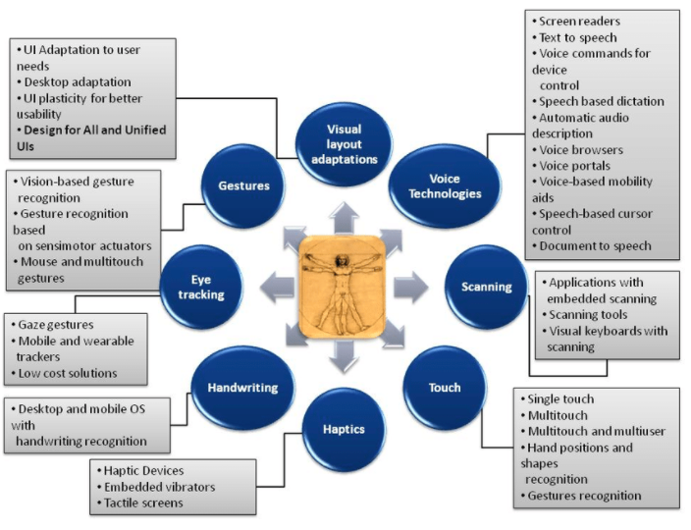

Graph by Margetis et al. 2012, https://www.researchgate.net/figure/Assistive-technology-categories_fig3_288274418

In pair with the respective communicated content, the system becomes complex and in relation to urban public transport is by no means a trivial issue. Christian puts the challenge forward that solving these interoperability issues and ensuring accessibility across systems could be the unique selling proposition for AT today.

Solving the interoperability issues and ensuring accessibility across systems could be the unique selling proposition for AT today.

However, to achieve this goal a coherent approach in AT-related standardization will be needed, as opposed to the current fragmentation where AT-related aspects are dealt with in many different fields but without overarching coordination. Hence, Christian’s proposition for a dedicated AT-related standardization ecosystem.

From the transport providers’ side, Steven Barbosa from the International Association of Public Transport (UITP) confirmed, that the transport sector is very aware that 17.6% of the EU population are living with a disability and that this share is likely to increase with an ageing population.

Furthermore, on European level we have legislation both general and specific to the transport sector to ensure the inclusion of persons with disabilities. These legal requirements as well as political attention have been accompanied by higher investment in accessible public transport. However, pitfalls persist such as the lack of a common definition for “reduced mobility” or “severe disability”. Interpretations are different amongst EU Member States, and even within in some of them at regional and local levels.

Pitfalls persist such as the lack of a common definition for “reduced mobility” or “severe disability”. Interpretations are different amongst EU Member States, and even within in some of them at regional and local levels.

Without clear definition, it becomes difficult for transport providers to hit the target. Also, it makes it difficult to get a clear picture of the overall situation. When the European Commission wanted to analyse accessibility for persons with disabilities in the EU, out of 77 cities only 32 could provide information on the type of accessible services they offer. The European Parliament’s research on accessibility in public transport and tourism in Europe highlighted that there is a general lack of accessible information, low use of applications and social media by public transport operators, low accessibility in sub-urban and rural areas, as well as significant barriers in inter-model hubs (when changing from one mode of transport to another).

In Europe, we find a great number of public transport systems. Some are accessible, many are still not, and it needs to be taken into account that some of the transport networks are over a century old. Nonetheless, major progress has been made in vehicle technology, ramps, lifts and kneeling systems. In regard to communication, colour contrasting, visual and audible information systems for people with sensory impairments are increasingly implemented, as well as beacon system to help people navigate in the network.

A definite shift has also occurred over the past years when transport providers started to assign dedicated personnel to deal with questions around accessibility and inclusion of groups of society that tend to be more excluded. This change of culture within the transport providers has led to a change in communication with the passengers, engagement with civil society as well as a different approach to designing both networks and vehicles. Several pilot projects in cities around Europe test both the roll-out of more accessible and assistive technologies as well as better training of staff to appropriately address passengers’ needs.

There are wonderful examples of local, even regional solutions. However, today people with disabilities also travel increasingly internationally and face the issue that most of the solutions that work for example in Paris will not work in Munich or New York or any other city.

And indeed, there are wonderful examples of local, even regional solutions. However, today people with disabilities also travel increasingly internationally and face the issue that most of the solutions that work for example in Paris will not work in Munich or New York or any other city. On this point, Christian emphasised again the need for standardisation on both application side as well as content side. This brings the challenge that content must be coded in a way that it can become interoperable and that a person would be able to travel to different places and have their personal device be able to understand the messages, train numbers, announcements and any other relevant information in the transport network they are traveling in.

This indeed is one of the biggest challenges to address because public transport is organised on regional level and split into many different systems. It is an open question today how transport operators can or will want to share data and information amongst each other.

To get more perspectives on the questions and challenges outlined in the presentations, Sabine Lobnig then introduced a panel of five international experts coming from Austria, France, Switzerland, the United States and Saudi Arabia, and covering in their expertise diverse areas from assistive technology, ambient assistive living, healthy aging to smart cities, passing by accessibility and web accessibility standards.

Prof. Gregg Vanderheiden pointed out that rather than talking about assistive technology, we should focus on accessibility in this context. Gregg is professor in the School of Information Studies (iSchool) at the University of Maryland, co-director at Raising the Floor, an international consortium of over 50 companies and organizations building the Global Public Inclusive Infrastructure (GPII), and has over 50 years of experience in accessibility.

We call a screen reader assistive technology, but when the screen reader comes as feature in a mainstream device we talk about universal design, or again, accessibility. The important thing though is that the user can get the information he or she needs and that we in fact have an eco-system of accessibility.

The important thing though is that the user can get the information he or she needs and that we in fact have an eco-system of accessibility.

Let’s take the example of self-driving cars. Once they arrive on the market, we will need them to be designed in a way that all people – with or without disabilities, old or young – can get into the car and be able to “drive” it, whether that means that they can interact with the car directly, or whether the car has AT, or whether the AT the rider brings with them works with the car.

This is the kind of ecosystem the previous speakers were talking about: a combination of separate standards and regular standards and regulations, depending on the best mechanism for any given situation. For a person with a mild vision impairment this means a slightly bigger display or larger print will do, while a person with strong vision loss or blindness might have to bring their own AT to connect with the car if it does not provide built-in AT.

Going back to the idea of the ecosystem, we currently see many different projects mapping cities for their accessibility. But we need a standardized way of accumulating this data. Otherwise a person traveling from one city to another will again not be able to tap into this information. This means that an ecosystem needs to bring the stakeholders together on all different levels (within a city, amongst different cities, amongst experts and interest groups and municipalities etc.).

The current times (reference to the global pandemic and resulting movement restrictions) show clearer than ever how important it is for people to be able to go to the places they need to be and have those places adapt to them appropriately whether that is for work or independent living. And since all different parts of the infrastructure need to play together for this to happen, an ecosystem for accessibility is certainly a more promising approach than looking at each part individually.

Jumping two world regions from North America to the Middle East, Aya Abdullah Jibreal shared perspectives from her experience working in Saudi Arabia and the Gulf countries. Aya is Inclusion and Accessibility Consultant with AlQemam Consultants and representative of G3ict’s Smart Cities for All global initiative.

While the TRIPS project identified 250 common barriers in public transport, you can multiply this number by 10 for the Middle East, Aya says. Currently, there are hardly minimum requirements for accessibility in place for public transport in the Gulf countries, also because the public transport system is not as developed in these countries as it is in Europe for example. But that is all the more an opportunity to take a holistic approach on public transport, ensure accessibility and also look at what is happening in the backend of theses systems.

We need to consider three main aspects when trying to make public transport accessible: system responsiveness, role of mainstream apps, and people traveling in foreign environments (tourists).

Aya underlined three main aspects to consider when trying to make public transport accessible: system responsiveness, role of mainstream apps, and people traveling in foreign environments (tourists). Can we ensure quick responses in our transport systems in cases of emergencies or unforeseen events? What mainstream apps can serve as AT or in general improve accessibility? For example, Google Maps has the advantage of being a globally used app as opposed to local accessibility maps that are limited in their reach. And how do we deal with people who are traveling in foreign environments where they might not understand the language and hence face temporary disabilities?

Mobility is an important human need and according to the UN Convention on the Rights of Persons with Disabilities a human right. Hence, we have the moral and legal obligation to think about how to improve public transport for everyone, said DI Christoph Veigl. He is researcher and lecturer at the University of Applied Sciences Technikum Wien in Austria, where he founded the research group for Assistive Technology and Smart Homes.

When we put accessibility and the way AT interacts with IT systems in the centre of IT development and have the necessary standards at hand and implemented, we might be able to ensure that devices in general and AT in particular work and are interoperable across borders.

He thinks that the ecosystem for assistive technology standardisation as mentioned by Christian and the holistic approach to accessibility as advocated by Gregg fit well together. When we put accessibility and the way AT interacts with IT systems in the centre of IT development and have the necessary standards at hand and implemented, we might be able to ensure that devices in general and AT in particular work and are interoperable across borders – whether these are geographical or technological in nature. This is not only important in public transport where almost each city creates their individual system, but also more and more relevant in Smart Homes, where barriers towards interoperability and accessibility of Smart Home related devices have actually increased in the past years!

A non-negligible challenge is to convince service providers and manufacturers to apply the relevant standards. We do have useful standards for accessibility and AT, such as the harmonised European standard EN 301549 for digital accessibility. But how many manufactures have it implemented in their devices? The bigger challenge to creating an ecosystem for AT standardization might indeed be to ensure that existing standards progress into products to make these accessible and available on the market.

The bigger challenge to creating an ecosystem for AT standardization might indeed be to ensure that existing standards progress into products to make these accessible and available on the market.

We do have great assistive technology available today, but how much do they really help if even with a computer science degree it is difficult and time-consuming to program them for the individual purpose you need them for? Shadi Abou-Zahra shared his experience with buying new wheels with an electric motor inside for his wheelchair. It took a lot of time and effort to program the wheel with all the necessary parameters from how quickly it should react to how much it should support the wheelchair etc. Shadi works with the W3C Web Accessibility Initiative (WAI) as the Accessibility Strategy and Technology Specialist.

So Shadi did manage to program his wheels, but winter came and he did not use them. After winter it so happened that the configurations had reset and that the app had been updated and did not work on his device any longer. What Shadi’s story shows is that user interfaces are crucial – they need to be accessible and easy to use, no matter if we are talking about electric wheels, a ticket machine or a smart home device.

User interfaces are crucial – they need to be accessible and easy to use, no matter if we are talking about electric wheels, a ticket machine or a smart home device.

User interfaces are key and they need to be accessible and interoperable – not only in their content but also in their underlying technology. APIs, machine to machine communication, the whole idea of coming to a bus in France and the bus understands my Austrian smart wheelchair and knows to drive out the ramp. This interoperability and accessibility need to be international, cross-borders and based on open standards.

This is where the web comes in and Shadi’s day-to-day job. When people hear about web accessibility they actually think about the Web Content Accessibility Guidelines which give guidance on accessibility at user-interface level. But the majority of W3C’s work is on getting accessibility features into HTML and core technologies of the web to make interoperability possible. This ideally results in universal accessibility features in mainstream technologies such as the keyboard shortcut “control +” which helps to increase text on almost any device.

Indeed, there is the concept of the Web of Things, which would be an extension of the Internet of Things (IoT). If the web is the primary interface to the “traditional” internet, the Web of Things could be the primary interface to the Internet of Things and help things connect on this platform, ensuring interoperability by using open data, semantic web technologies and the likes to allow machine and humans to communicate. This circles back to what Aya said about mainstream apps like Google, which indeed pulls in a lot of data across the globe – including information on accessible locations and transport services.

We need both an ecosystem for AT standards as well as mainstream accessibility, but also international coordination.

In summary, Shadi says, we need both an ecosystem for AT standards as well as mainstream accessibility, but also international coordination. Because today we do not have one single organisation or standards body that would be able to control or manage the Internet of Things. The Internet of Things is a decentralised international effort and that is good, but we need to have an understanding of where we are with accessibility and AT, where we have gaps in accessibility in mainstream technologies, what additional accessibility standards for AT we need. There once was a special interest group at ISO who tried to do just that but was discontinued. Maybe we should strive for having a similar effort taken up again to ensure this much needed international coordination among the many stakeholder groups involved.

Our accessibility and AT experts from three world regions have given us a rich picture of the current status of content and communication accessibility in public transport, but are there any aspects we might be overlooking still? One of these aspects might indeed be demographics, says Dr Astrid Stuckelberger, researcher and professor in public health sciences at the Faculty of Medicine of the University of Geneva and internationally recognized expert in ageing, innovation and global public health issues.

Everyone knows that our populations are ageing and from formerly three generations living in parallel, we are now dealing with five generations, 2-3 out of them ageing. And in this regard, standardisation is a trap. Each time we generalise, we tend to go for the mean, disregarding the most potent members of the group and the most vulnerable members of the group. We standardise for the average in the middle in the hopes this will make things work for everyone. But that is not the case. In particular when it comes to ICT, the ageing 2-3 generations would need it most for support and help in their daily live, but are at the same time the most vulnerable and least educated in this area. The engineers are always technology centred. But we need to be human centred, and in this context consider the demographics we are developing products and services for.

Standardisation is a trap. In particular when it comes to ICT, the ageing 2-3 generations would need it most for support and help in their daily live, but are at the same time the most vulnerable and least educated in this area.

If we take ageing only as a bio-marker and not as the discriminative factor as which it is experienced by the ageing generations, we are misguided. Because this mixes people who are healthy and interested in having access to technology and using all opportunities that come with that, with people who are on the opposite spectrum in their health and might have Alzheimer’s or Parkinson’s and are mentally and functionally disabled. Which standard can ensure access to public transport for both of these extremes at the same time?

In making public transport accessible to all, we might get inspired by the corner stones AAAQ for the right to health in the UN Convention. AAAQ stands for accessibility, availability, adapted to the person and of quality. On top of these, we need to consider data protection and privacy, and then factor in the exponential technological and medical improvements of today’s world.

Astrid’s emphasis of the human centred approach found support among the other speakers, but they also felt that standards in this context can be really helpful to further a common understanding and provide definitions so that everyone understands what we mean when talking about accessibility or a person with mobility impairment.

A rich discussion which is difficult to summarise in only a few words, concluded Evert-Jan Hoogerwerf, Secretary General of AAATE. Everybody agreed that we need an ecosystem that incorporates both AT and accessibility as well as usability and human-centred design. We also identified a range of challenges from the integration of devices, user interfaces and data to the interoperability of software and information systems, and touched upon the issue of specifically designed AT versus accessible mainstream technologies. Clearly this is not the end of the discussion but rather a starting point and the invitation to dig deeper and explore how we can fit the pieces together so that one day public transport may be easy, accessible and frictionless for all users, with and without disabilities.

The discussion was continued in follow-un interviews that allowed to go further into depth on some of the aspects mentioned in the workshop. A summary of the interviews with Christoph, Gregg and Aya in the weeks after the workshop will be published as sequel to this report.

Whoever would like to be part of more in-depth discussions on how AT standards can and need to play a role, is invited to join AAATE’s Special Interest Group on Standards.

Communication in Accessible Urban Public Transport: Workshop on standardisation activities concerning interfaces and communicated content, 10 September 2020

Speakers bios

Key note session. Moderator David Banes (AAATE inhouse consultant)
- Laura Alčiauskaitė (TRIPS project coordinator for the European Network of Independent Living): TRIPS project: User involvement in identifying barriers while using the public transportation – primary results

Laura Alčiauskaitė is TRIPS project coordinator for the European Network of Independent Living with more than 10 years of experience on fields of disability, social inclusion and accessibility. Laura is a PhD student in Psychology at Vytautas Magnus University in Lithuania. Her PhD thesis is focused on positive psychology and is about psychological resources and their impact to acceptance to disability among people with mobility disabilities. She also works as a Human Rights activist since 2012, especially focusing on the implementation of human and social for people with disabilities.

Please click AAATE workshop presentation – Laura to see the slides presented by Laura Alčiauskaitė
Connect with Laura: https://www.researchgate.net/profile/Laura_Alciauskaite

- Steven Barbosa (Senior Manager- Business, HR & International Social Affairs, International Association of Public Transport UITP): Public Transport and standardisation.

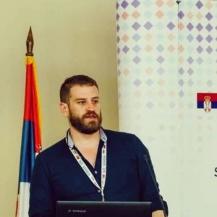

Steven Barbosa is a Senior UITP Manager. He is in responsible for the Business and Human Resources Committee and for the European and International Social Dialogue affairs. Besides that, Steven Barbosa is also the manager of the UITP Marketing and Product Development Committee. Steven Barbosa has a background in political science and international relations with professional experience in the European Council and Parliament. Steven Barbosa also has experience as a consultant and as a Non-governmental and as well political organizations.

Please click AAATE WORKSHOP FINAL PRESENTATION SMB UITP to see the slides presented by Steven Barbosa
Connect with Steven: https://www.linkedin.com/in/steven-barbosa-2886324b/

- Christian Galinski (Leader of the AAATE Standardisation SIG and project consultant of AAATE for the TRIPS project): Accessible communication and content interoperability in urban public transport.

Christian Galinski studied languages and I&D (information and documentation) and graduated in Japanese studies. In 1979 he joined the International Information Centre for Terminology (Infoterm) as expert. In 1986 he became Director of Infoterm and Secretary of the Technical Committee ISO/TC 37 “Language and terminology” of the International Organization for Standardization (ISO). Participation in EU projects focused among others on technical communication aspects, the role of language services and the language industry, language and terminology policies, structured content in eApplications, and copyright issues. Since 2010 projects focused on communication with and among persons with disabilities (PwD), as well as related standardization issues. Since many years C. Galinski works as consultant for national, European and intergovernmental organizations (IGO), such as UNESCO, as well as numerous non-governmental organizations (NGO) world-wide, including ISO.
Please click ICCHP-AAATE workshop_2020_v0-8_Galinski to see the slides presented by Christian Galinski

Connect with Christian: https://www.linkedin.com/in/christian-galinski-56b46856/

Panellists

- Gregg Vanderheiden (Raising the floor and Global Public Inclusive Infrastructure Project)

Gregg Vanderheiden is a Professor in the School of Information Studies (iSchool) at the University of Maryland, College Park, and Director of the Trace Research & Development Center at the University of Maryland, and co-directs Raising the Floor, an international consortium of over 50 companies and organizations building the Global Public Inclusive Infrastructure (GPII). Has worked in technology and disability for over 45 years; was a pioneer in Augmentative Communication (a term taken from his writings in 1979) and computer access. Most of the initial access features for both Windows and MacOS came from his Center. His can be in a wide range of products including computers, phones, Automated Postal Stations, Amtrak ticket machines, and airport communication terminals. He co-chaired both WCAG 1.0 and 2.0 working groups, and has worked with over 50 companies and numerous government advisory & planning committees including FCC, NSF, NIH, GSA, NCD, Access Board and White House. (Dr. Vanderheiden will be joining the faculty of the iSchool at University of Maryland – College Park the fall.)

Connect with Gregg: https://www.linkedin.com/in/gregg-vanderheiden-bb11085/

- Aya Abdullah Jibreal (Inclusion and Accessibility Consultant at AlQemam Consultants)

Aya is an Inclusive Design and Accessibility Consultant/Trainer with 7 years of experience in inclusion and accessibility. Aya worked with many entities around Saudi Arabia, exploring how accessibility can be successfully adopted in different business environments. Saudi Arabia representative at G3ict/Smart Cities for All global initiatives. First CPACC certified in Saudi Arabia. Certified in disability case management. IAAP Strategic Leader in Accessibility (SLiA) initiative committee member.

Connect with Aya: https://www.linkedin.com/in/ayajibreal/

- Astrid Stueckelberger (Scientist and international health expert)

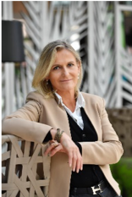

Dr Astrid Stuckelberger is an internationally recognized expert in ageing, innovation and global public health issues. PhD in population health and Privat-Docent of medicine, she is a researcher and professor in public health sciences at the Faculty of Medicine of the University of Geneva and Lausanne for 20 years, she directs several international and European projects, training and communication for the public. For example, she is regularly invited as an EU expert on ICT, Innovation and ethics/regulation for seniors for the EU, national institutions (i.e. AAL, FFG) or private sector R&D. Within the United Nations, she has for example been working with WHO department on ageing, mental health, social determinants, international health regulations (pandemics) and ethics. She was awarded by the United Nations Secretary-General for her achievements with the Geneva International Network on Ageing (GINA), which she currently chairs. Author of a dozen books and more than 200 scientific articles, policy papers, governmental, European Commission or UN reports.

Connect with Astrid: https://www.linkedin.com/in/drastridstuckelberger/

- ShadiAbou-Zahra (W3C Web Accessibility Initiative (WAI))

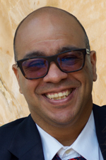

Shadi Abou-Zahra works with the W3C Web Accessibility Initiative (WAI) as the Accessibility Strategy and Technology Specialist. He coordinates accessibility priorities in the W3C Strategy team, as well as international promotion, coordination, and harmonization of web accessibility standards. Shadi also maintains WAI liaisons with key stakeholders including disability, research, and standards organizations, as well as coordinates WAI outreach in Europe, accessibility evaluation techniques, and European-funded projects on accessibility.

Connect with Shadi: https://www.linkedin.com/in/shadiabouzahra/

- Christoph Veigl (Technikum Wien)

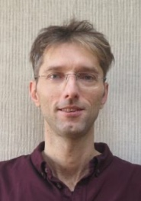

Christoph Veigl works as a researcher and lecturer at the University of Applied Sciences Technikum Wien, where he founded the research group for Assistive Technology and Smart Homes. Since 2010, Chris Veigl has been leading national and international research and development projects in the areas of AT and AAL. He presented Assistive Technology solutions in various locations around the world. His technical expertise includes software engineering and firmware development for embedded systems, system architecture and design of embedded systems as well as implementation of human-machine interfaces using hardware/software technologies.
Christoph Veigl is chairman of the AsTeRICS Foundation for Open Source Assistive Technologies and heads the competence network of the AAL Austria initiative and the knowledge center for barrier-free technologies.

Connect with Christoph: https://www.linkedin.com/in/christoph-veigl-b535203/

